PDS Assignment
Marks : 7
Total_Mark column is not calculated
Comment and Insight missing
Since the data is continuous , freq polygon would have been also a good plot

Code:-

library(readxl)
library(dplyr)
library(ggplot2)
library(cowplot)

StudP = read_excel("C:/Users/Admin/Documents/R/Projects/StudentsPerformance.xlsx")

View(StudP)

head(StudP)

tail(StudP)

summary(StudP)

nrow(StudP)

str(StudP)

print(StudP)

group_count = StudP %>% count(group)

group_count

StudP %>% filter(is.na(group))

StudP %>% filter(is.na(gender))

StudP %>% filter(gender=='male' & group == 'group B')

StudP %>% filter(group == 'group B' & math_score == 40)

new_StudP = mutate(StudP,average_score = round((math_score+reading_score+writing_score)/3))

new_StudP$average_score

head(new_StudP)

View(new_StudP)

#Answer 1
agg_math_score = aggregate(new_StudP$math_score, list(StudP$group), FUN=mean)

colnames(agg_math_score) <- c('group','avg_math_score')

agg_math_score

Output: -

group avg_math_score
1 group A 61.62921
2 group B 63.45263
3 group C 64.46395
4 group D 67.36260
5 group E 73.82143

agg_reading_score = aggregate(new_StudP$reading_score, list(StudP$group), FUN=mean)

colnames(agg_reading_score) <- c('group','avg_reading_score')

agg_reading_score

Output: -

group avg_reading_score
1 group A 64.67416
2 group B 67.35263
3 group C 69.10345
4 group D 70.03053
5 group E 73.02857

agg_writing_score = aggregate(new_StudP$writing_score, list(StudP$group), FUN=mean)

colnames(agg_writing_score) <- c('group','avg_writing_score')

agg_writing_score

Output: -

group avg_writing_score
1 group A 62.67416
2 group B 65.60000
3 group C 67.82759
4 group D 70.14504
5 group E 71.40714
agg_average_score = aggregate(new_StudP$average_score, list(StudP$group), FUN=mean)

colnames(agg_average_score) <- c('group','avg_student_StudPormance')

agg_average_score

dev.off(dev.list()["RStudioGD"])

p1 = ggplot(agg_math_score, aes(x=group, y=avg_math_score, fill=group)) + geom_bar(stat="identity") +
labs(x="Groups", y="Average_Math_Score")

p2 = ggplot(agg_reading_score, aes(x=group, y=avg_reading_score,fill=group)) + geom_bar(stat="identity") +
labs(x="Groups", y="Average_Reading_Score")

p3 = ggplot(agg_writing_score, aes(x=group, y=avg_writing_score,fill=group)) + geom_bar(stat="identity") +
labs(x="Groups", y="Average_Writing_Score")

p4 = ggplot(agg_average_score, aes(x=group, y=avg_student_StudPormance,fill=group)) + geom_bar(stat="identity") +
labs(x="Groups", y="Average_Student_StudPormance")

plot_grid(p1,p2,p3,p4,labels="AUTO")

Output: -

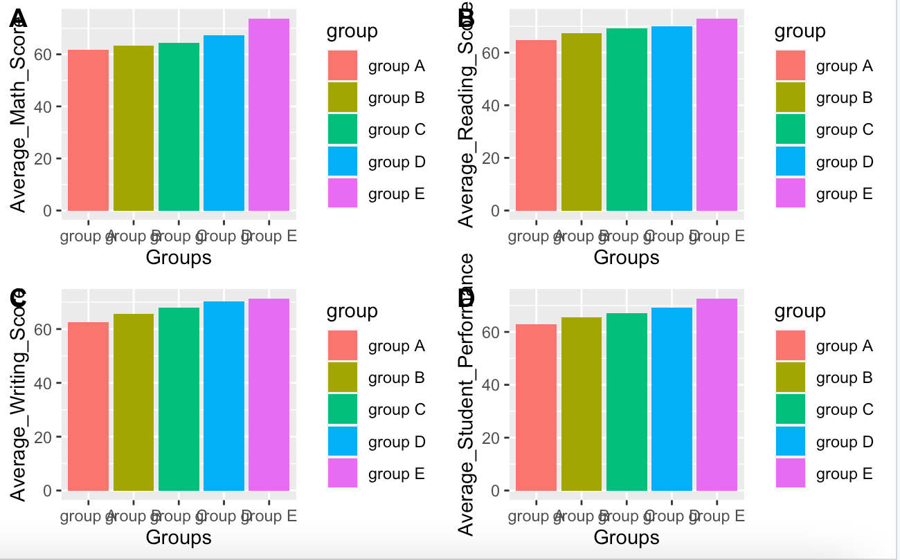

#Answer 2

dev.off(dev.list()["RStudioGD"])

grp_avg_bar = StudP %>% group_by(group,gender) %>%
summarise(avg_math = mean(math_score))

grp_avg_bar

ggplot(grp_avg_bar,(aes(x=group,y=avg_math,fill=gender))) +
geom_bar(stat = "identity",position = "dodge")

Output: -

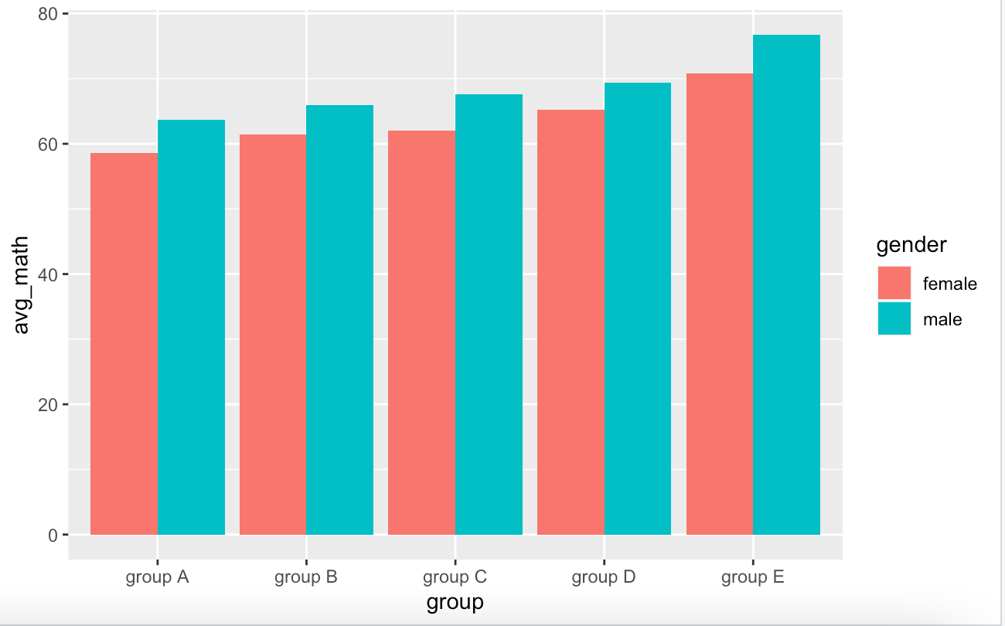

#Answer 3

total_StudP = mutate(StudP,total_marks = (math_score+reading_score+writing_score))

total_StudP$total_marks

head(total_StudP)

grp3_total = total_StudP %>% group_by(group,gender) %>%
summarise(sum_total = sum(total_marks))

grp3_total

ggplot(grp3_total,(aes(x=group,y=sum_total,fill=gender))) +
geom_bar(stat = "identity",position = "dodge")

output :-

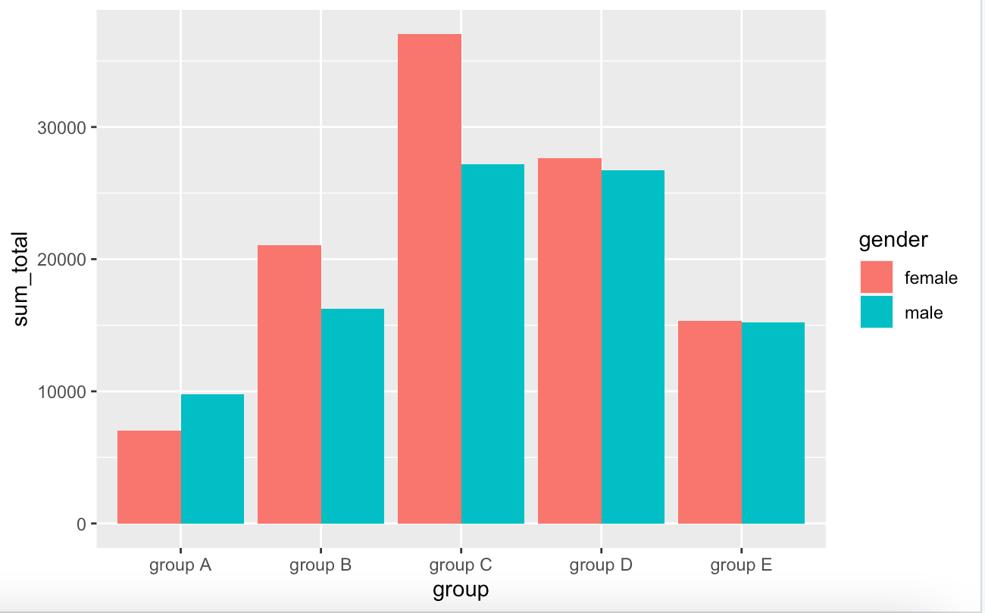

sum_box=ggplot(total_StudP, mapping=aes(x=group, y=total_marks))+geom_boxplot()

sum_box

Output: -

